EMAIL 1
IMAGE HEADER:

Join United Way of Snohomish County in leading the way for a better future for all by donating today.
Your support of United Way of Snohomish County will allow us to advance health, youth opportunity, and financial security to ensure our neighbors can thrive. Our work is powered by generous supporters, like you and INSERT YOUR COMPANY NAME HERE, who are committed to #LeadingTheWay to a stronger community.
Because of your generous support, United Way of Snohomish County is making a difference in the lives of thousands of people every year. We need you with us. Donate today and join us in Leading the Way to a better future for all.
BUTTON TEXT: LEAD THE WAY (contact UWSC Team to set up a donation link)

EMAIL 2
IMAGE HEADER:
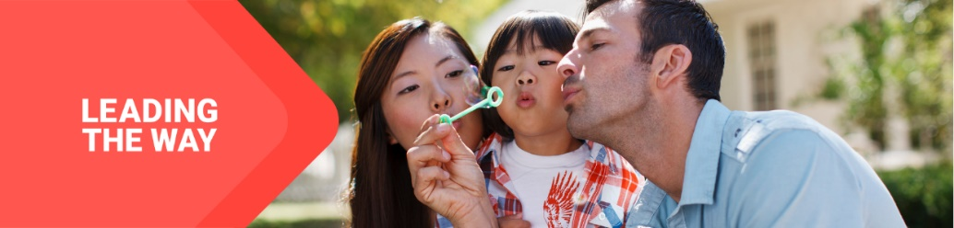
United Way of Snohomish County supports Dolly Parton’s Imagination Library, which mails FREE and high-quality books to children in Snohomish County, from birth until their 5th birthday, no matter the family’s income. In fact, in our first year of partnership, over 100,000 books were shipped to children all over our county and this number is growing every month.
Our goal is that all early learners have developed a quality, inclusive home library, are inspired to read, ready to learn, and are excelling academically, creating a thriving child and a vibrant, healthy community.
Parents and guardians are a child’s first teacher and by providing books every month at no cost to families, the Imagination Library increases childhood literacy rates, fosters a love of books, and promotes a culture of reading among all families in Snohomish County. Currently, 11,000 children across our county are receiving these books, directly to their homes!
BUTTON TEXT: DONATE TODAY (contact UWSC Team to set up a donation link)

EMAIL 3
IMAGE HEADER:
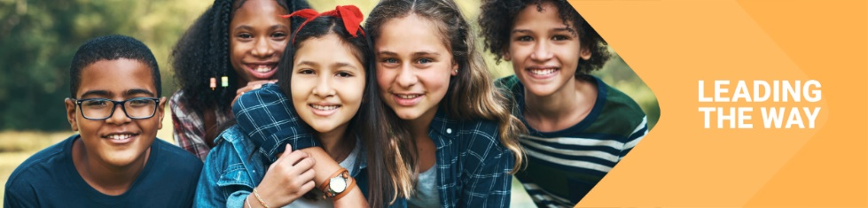
We need you with us-- whether you’re new to United Way of Snohomish County or you’ve been creating impact with us for years. At United Way, we believe that everyone who lives and works in Snohomish County deserves the opportunity to thrive. Together with you and partners like INSERT YOUR COMPANY NAME HERE, United Way mobilizes the caring power of people to create transformational change.
Day in and day out, United Way of Snohomish County supports programs like Best Dental Help, a nonprofit organization dedicated to providing dental care to uninsured elementary children in Snohomish County and surrounding regions. We’re proud of all we’ve accomplished together. Last school year:
- 4,240 elementary-aged students received critical education around proper dental care
- Over 75% of all students who opted in to receive treatment had dental decay, visible concerns or urgent needs that were able to be addressed and treated.
- 2,634 sealants were placed on non-permanent teeth (a process not normally covered by insurance), helping to prevent future dental decay.
- 1,500 students whose families and caregivers did not have dental insurance were able to receive screenings, cleanings and fluoride treatment – sometimes the only dental care they receive all year long.
More work is needed to build on this momentum. If you’ve already given, thank you. If you haven’t, there’s still time to join in. Together, let’s Lead the Way and make great things for people who call Snohomish County home.
BUTTON TEXT: Donate (contact UWSC Team to set up a donation link)

EMAIL 4
IMAGE HEADER:

United Way of Snohomish County mobilizes our neighbors and partners to action so that all can thrive. Whenever there’s a need in our community, United Way is there. We are all about creating a future where everyone, everywhere can rise regardless of race, place or ability. Thanks to supporters like you, we can continue being a funder, active partner, and convener around intentional collaborative solutions that create lasting community change.
And we’re not stopping there. Your support can help continue tackling the biggest problems in Snohomish County. From education and health to advocacy and community resiliency, we bring a comprehensive approach to every challenge. Almost 85 years of experience has shown us that when people unite to take action, change is possible.
Join us in Leading the Way to a better future for all.
BUTTON TEXT: Donate Today (contact UWSC Team to set up a donation link)

EMAIL 5
Image Header:


Through strategic partnerships and collaborative work, United Way of Snohomish County brings the many voices of our community together to find common ground and develop strategic plans for change. Your commitment to this year’s campaign will give your neighbors the programs and services they need.
From strengthening local resilience to advancing health, youth opportunity, and financial security, your support is integral to creating impact in our community. Thank you for chipping in and Leading the Way to a better future for everyone in Snohomish County.
By coming together, we can do so much more to accomplish goals that can change lives
BUTTON TEXT: Donate Today (contact UWSC Team to set up a donation link)

EMAIL 6
Image Header:
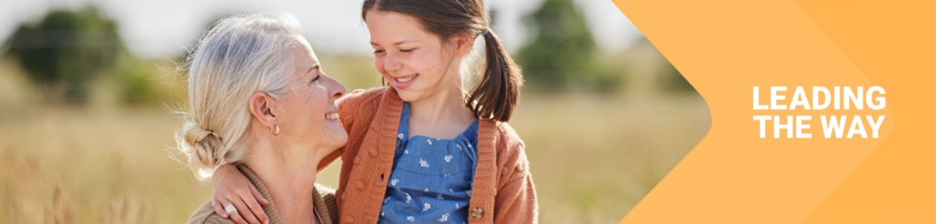
Whether you are interested in the impact of early literacy, access to dental care for young kids, or creating lasting change in our community, United Way of Snohomish County gives you an opportunity to make a direct impact on the issues you care about.
Through United Way of Snohomish County, you can help advance effective solutions to community challenges making life better for every person across the Snohomish County region. THANK YOU for your continued support of our organization and your community.
BUTTON TEXT: LEAD THE WAY (contact UWSC Team to set up a donation link)

